**Student’s Project**

**MOROCCO**



**A New Vision to the Teaching and Learning Process of Math**

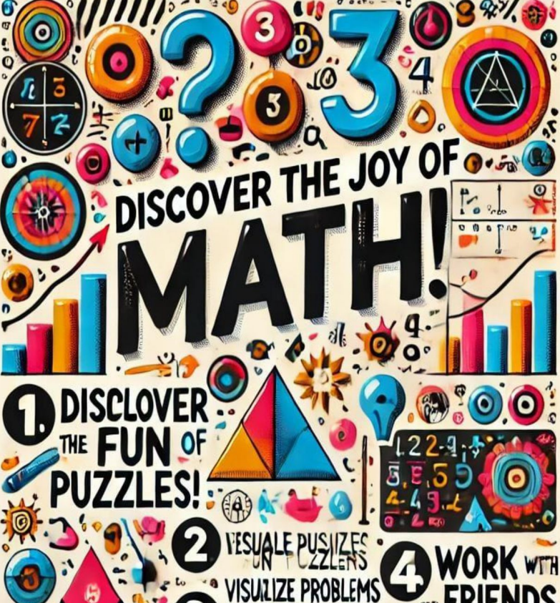

**The researcher : Imane Zaghdoud**

Supervised by : Prof. Mohamed Fettah

School: Moulay Ismail High School

**Outline**

1. **Part One (Theory) ...........................................................**
2. **Introduction.**
   1. The importance of Mathematics in our everyday life.
   2. Learning Mathematics throughout the years.
3. **Problems and challenges in learning Mathematics.**
4. In the teaching methodology.
5. In the textbook content.
6. In the studying conditions.
7. **New techniques for learning and teaching Mathematics.**
8. New learning strategies for students through fun and engaging activities.
9. Visualization techniques in learning Mathematics.
10. Problem-solving skills and real-life applications of Mathematics in teaching.
11. **Part Two (Practice) ....................................................**

* **Create a Poster About Loving Mathematics.**

Design an inspiring poster to promote the beauty and importance of Mathematics, featuring motivational quotes, funny facts, and visuals. This poster can be displayed in schools and community spaces to encourage a positive attitude toward Math.

* **Create a small book of guidelines for students of Mathematics.**

Write a book of guidelines for my community. The book offers pieces of advice on how to approach Mathematics with love and enthusiasm. The book also includes tips on how to succeed in learning Mathematics and to what extent it is used in our daily life.

**Abstract**

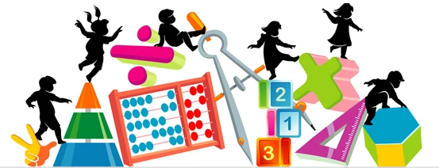

**Mathematics plays a vital role in our everyday lives by influencing various aspects of decision-making, problem-solving, and logical thinking. In fact, the approach to learning Mathematics has evolved over the years; however, many challenges still persist in the teaching learning process of Math. Therefore, this research explores the significance of Mathematics and highlights its importance not only in our daily life but also in the development of our country as a whole. It also examines common problems in learning Mathematics through analyzing issues related to teaching methodologies, textbook content, and studying conditions that hinder students’ progress and engagement.**

**To address these challenges, the study proposes innovative techniques for learning and teaching Mathematics. These include engaging students through fun and interactive activities, employing visualization techniques to enhance understanding, and integrating real-life applications to develop problem-solving skills. Indeed, these strategies aim to foster a deeper appreciation of Mathematics and improve educational outcomes.**

**In the practical section, the research involves creating tools for teaching and learning Mathematics. First, an inspiring poster is designed to highlight the beauty and importance of Mathematics. Second, a small book of guidelines is developed to offer students some pieces of advice for their academic success in learning Mathematics. Meantime, it illustrates the subject's relevance in everyday life.**

**In a nutshell, this research generally aims to cultivate a positive attitude toward teaching and learning Mathematics as well as encourage its appreciation within the community.**

"Mathematics is the unshakable foundation of all sciences and the means to understanding the truths of the universe."

Al-Khwarizmi